
RAMAIAH
Institute of Technology
USN | 1 | M | S

(Autonomous Institute, Affiliated to VTU)
(Approved by AICTE, New Delhi & Govt. of Karnataka) Accredited by NBA & NAAC with ‘A’ Grade

MAKEUP EXAMINATIONS – FEBRUARY 2019

Course & Branch | : | B.E: Electrical and Electronics Engineering | Semester | : | VII
Subject | : | Generation, Economics and Reliability Aspects of Power Systems | Max. Marks | : | 100
Subject Code | : | EEE20/EEPE42 | Duration | : | 3 Hrs

Instructions to the Candidates:
- Answer one full question from each unit.

 |  | UNIT- I
1. | a) | Explain the role of following units in nuclear reactor:  - Moderator ii) Reflector iii) coolants. | CO1 | (09)
 | b) | List out the applications of diesel power plants. | CO1 | (06)
 | c) | Enumerate the factors to be considered in selection of site in thermal power plants. | CO1 | (05)
2. | a) | Discuss the parts spillway and penstock of Hydro power plant . | CO1 | (07)
 | b) | Explain the usefulness of heat, sludge of thermal power plants. | CO1 | (07)
 | c) | List out the socio economic impacts of power plants. | CO1 | (06)
 |  | UNIT- II
3. | a) | Define plant capacity factor and diversity factor. | CO2 | (04)
 | b) | A factory has a maximum demand of 240kW at 0.8 power factor with annual consumption of 50,000units. The tariff is Rs 50/kVA of maximum demand plus 10 paise per unit. Calculate flat rate of energy conversion , what will be the annual energy savings if the power factor is raised to unity. | CO2 | (08)
 | c) | A generating station has a maximum demand of 75MW and load factor is 0.4.Generating cost is Rs60 per annum per kW of maximum demand plus 4 paise per kWh transmitted. Annual capital charges of transmission system are 20 lakhs and distribution system are 15 lakhs. Diversity factor of transmission and distribution system is 1.2 and 1.25.Transmission and distribution system are 90% and 85 % efficient. Find yearly cost per kW demand, cost at substation and consumer premises. | CO2 | (08)
4. | a) | Two electrical devices are used for the same purposes:  Cost of first device=Rs7000 and takes 90 kW.  Cost of second device=Rs18,000 and takes 50 kW  Useful life of each unit is=38,000hrs.Energy rate is Rs 100 per kW of maximum demand /Year and 8 paise per kWh. Find which device will be economical if both runs at same load. | CO2 | (08)
 | b) | It is proposed to supply a load with a maximum demand of 100MW with a load factor of 0.4. Following three alternatives are available. Calculate overall cost/kWH and suggest cost effective alternative. | CO2 | (08)
  Cost | Nuclear plant | Hydro plant | Steam plant
  Capital cost/kW installed | Rs 6000 | Rs 4320 | Rs 2160
  Interest | 10% | 10% | 12%
  Depreciation | 8% | 7% | 10%
  Operating cost /kWH | 12 piase | 6 paise | 18 paise
  Transmission & Distribution cost /kWH | 0.24 paise | 0.96 paise | 0.24 paise
 | c) | Discuss the evolution of energy market. | CO2 | (04)
 |  | UNIT- III
5. | a) | Define adequacy and Security aspects of reliability. Enumerate the difference between them. | CO3 | (06)
 | b) | Describe functional zones of power system. | CO3 | (06)
 | c) | For the following LDC curve shown in Fig 5(c), calculate the EIR with system having three identical units of having capacity 75 MW with FOR 0.025?  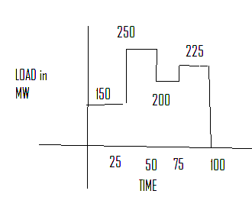  Fig. 5(c) | CO3 | (08)
6. | a) | List the factors effecting the reliability of the power systems. | CO3 | (06)
 | b) | Enumerate the difference between Two state and Three state model. | CO3 | (06)
 | c) | A power plant having four systems having two units a and b its state table is given below ,Draw the state transition diagram  (u-up and D-down) µ-repair rate λ-failure rate. | CO3 | (08)
  System | Units-a | Unit-b
  S1 | U | D
  S2 | D | U
  S3 | U | U
  S4 | U | D
 |  | UNIT – IV
7. | a) | Discuss the station originated outages. | CO4 | (03)
 | b) | Classify the maintenance in reliability. | CO4 | (06)
 | c) | A system having three units their capacities ,their failure rate &repair rate are given in the table below .Prepare a capacity outage probability table: | CO4 | (08)
  Unit | Capacity(Mw) | Failure rate | Repair rate
  1 | 50 | 1 | 99
  2 | 100 | 1 | 49
  3 | 200 | 1.1 | 72.23
 | d) | Answer the following with True/False:  i)VIP load can be curtail able load  ii)Peak load is supplied by Nuclear generation  iii) Switching surges causes a forced outrage of the system. | CO4 | (03)
8. | a) | Discuss the steps in adequacy evaluation of HL-II. | CO4 | (08)
 | b) | Classify the outages in power systems. | CO4 | (05)
 | c) | For the curve shown in Fig.8(c) find the EIR with system having two units with capacities 25MW & 50 MW which have repair rate as 0.49 f/year & failure rate as 0.01 f/year ?  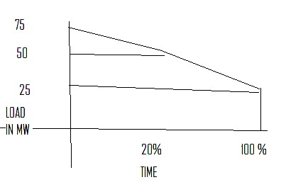  Fg.8(c) | CO4 | (07)
 |  | UNIT- V
9. | a) | Discuss the scenarios to be consider in analyzing the interruption scenarios for different customers. | CO5 | (10)
 | b) | Find SAIFI,SAIDI,CAIDI,ASAI for the following set of customer data: | CO5 | (10)
  Line | Failure rate | Interruption duration | No of customers | Avg load demand in kW
  A | 0.20 | 1.20 | 200 | 1000
  B | 0.30 | 1.68 | 150 | 700
  C | 0.45 | 2.88 | 100 | 400
10. | a) | Explain how interruption cost of commercial and industrial customer varies with different factors. | CO5 | (10)
 | b) | Define the terms: i) SAIFI ii) SAIDI iii) CAIDI. | CO5 | (06)
 | c) | Indirect cost contribute majorly than the direct cost during the blackouts to the economy of the country. Justify this with an example. | CO5 | (04)

****************

